Francisco Serrano

Web & App Development

Instructor Phap Bui

6/21/20

Lab 3_4

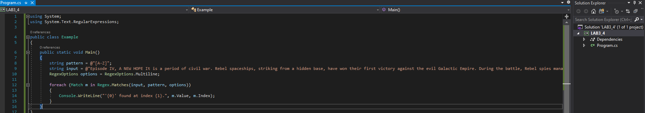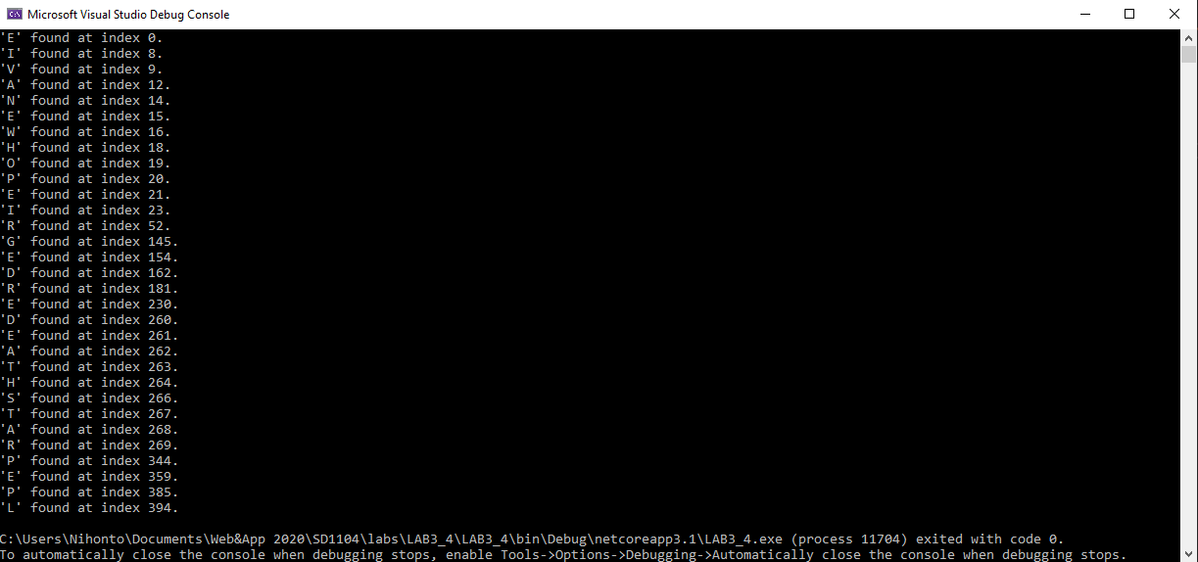

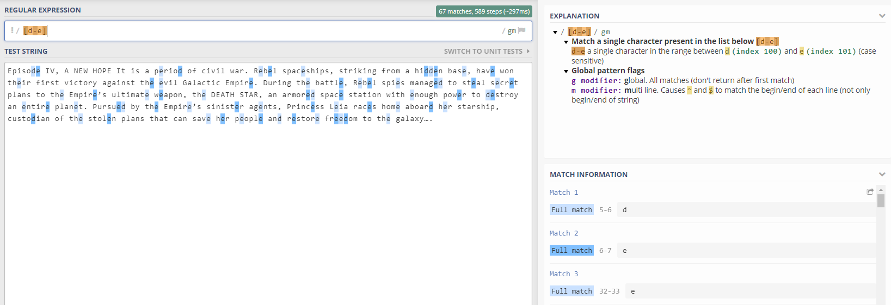

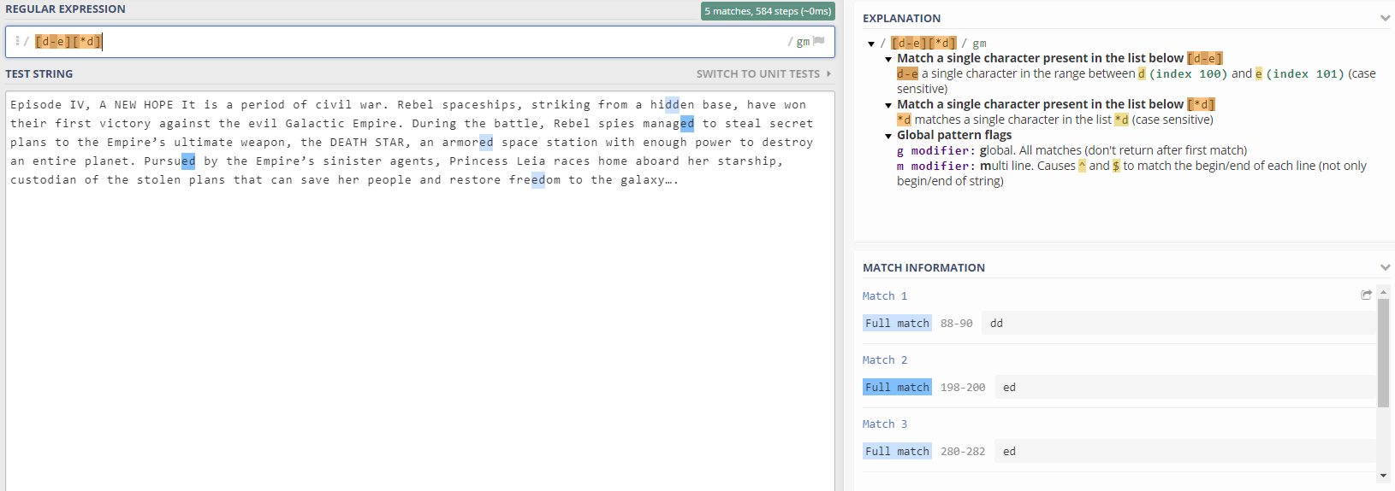

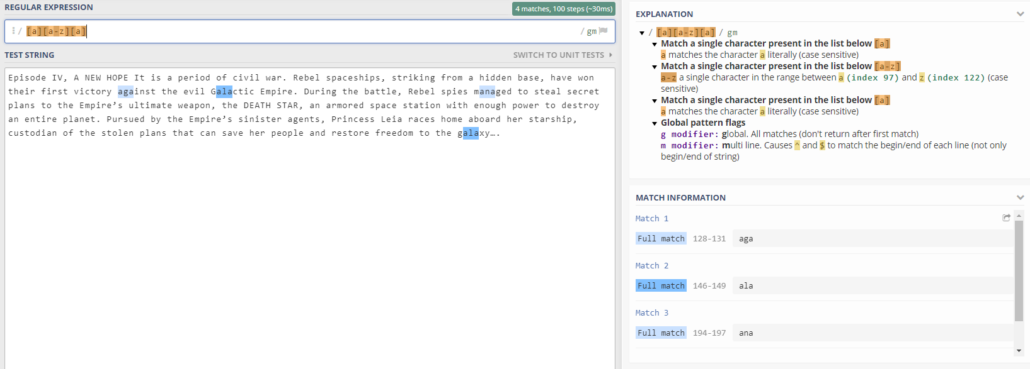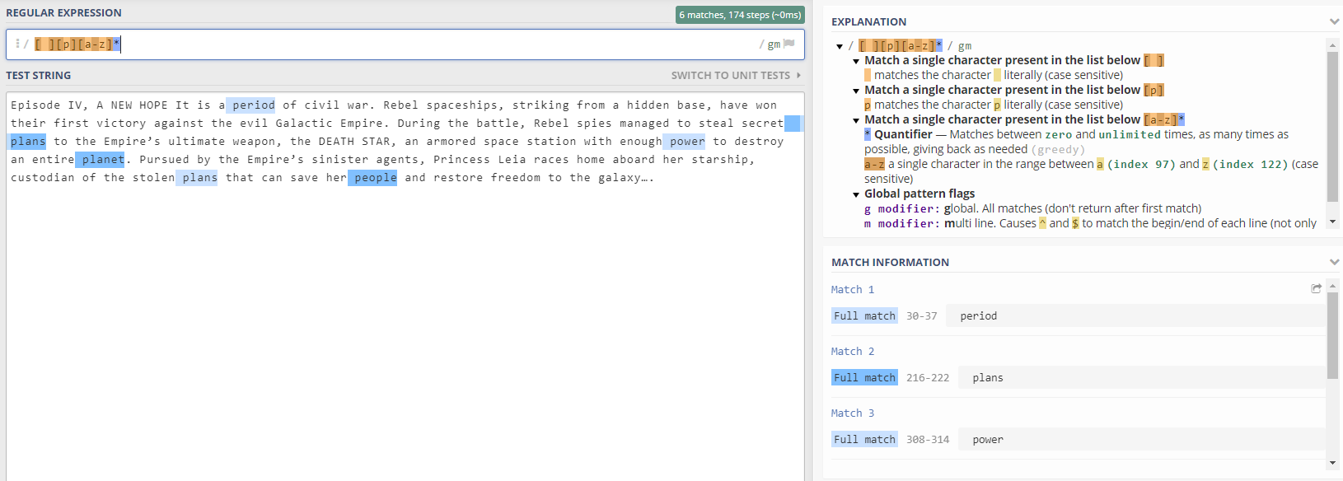

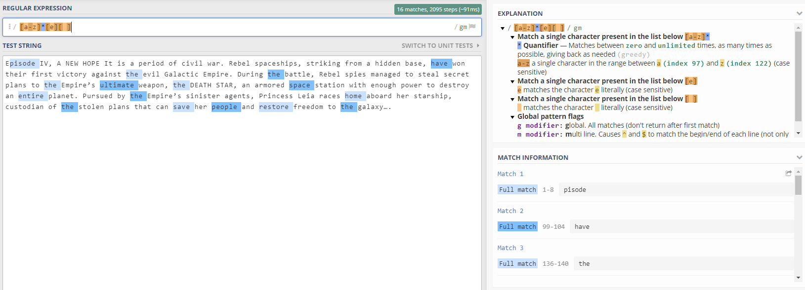

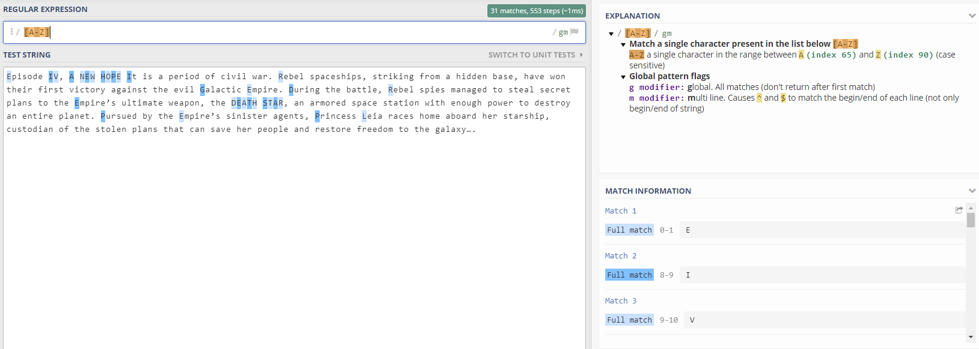

Summary:

In this lesson/lab, I learned about Regular Expressions and how they work with finding special keywords and characters. This could be very useful for detecting any wanted or unwanted attention from a potential customer to spam bots.